What to include within an
Education, Health and Care Needs Assessment Request

This document is a guide to support you with making a request for an EHC needs assessment.

Walsall local authority (SEN Team) require that the Parental/Young Person’s information is submitted for the for Education, Health and Care needs assessment request via their online EHC Hub.

When you wish to make a request, click the request a needs assessment tab as shown below.
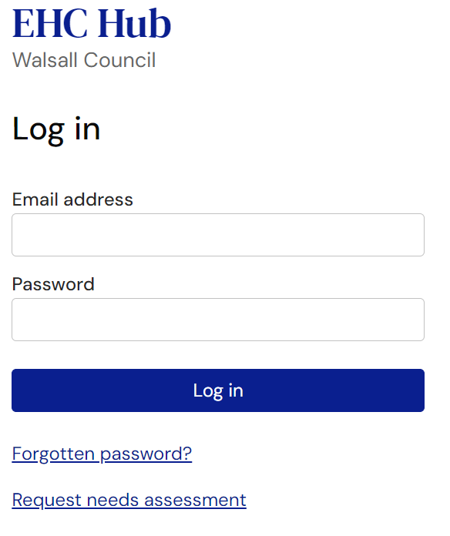

The information you provide will help Walsall local authority to understand your child’s strengths and needs as well as your concerns; it will also help them to know why you are making the request along with what needs to be done differently for things to improve.

You will then be presented with the following page – Think carefully about what you are going to say and be as detailed and concise as possible with your answers.
Please note that you cannot save progress as you move through the request so you will need to complete all fields in one go. It is helpful to think of everything you wish to include before starting and it can be useful to do this via another document which you can copy and paste onto the EHC hub.
Complete each section before sending your request.
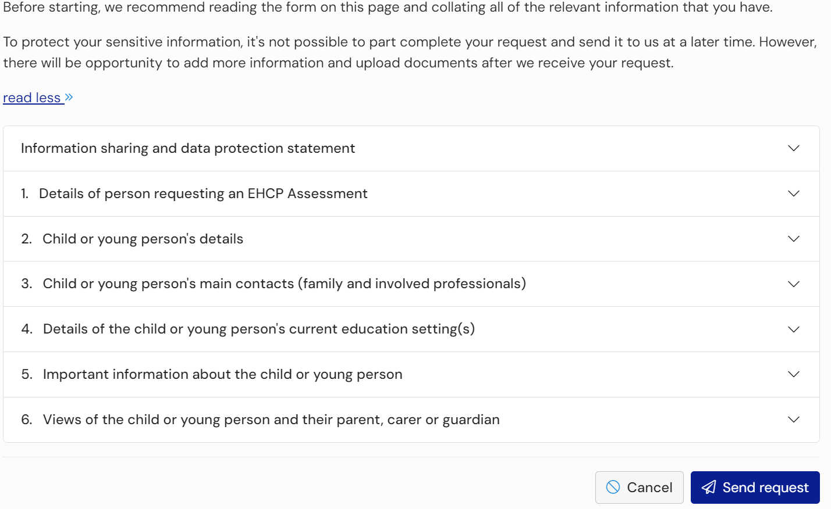

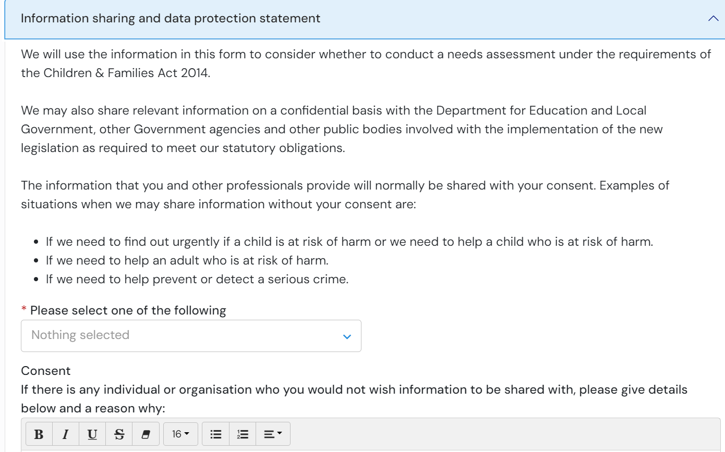
The first step is complete the data protection information and details of the person making the request (parent or young person over 16 years of age).

Section 1-
- This section is titled ‘Details of person requesting an EHCP assessment’
You can access this section by clicking the down arrow to the right of the screen. You can then minimise the section once you’ve completed it by clicking on the same arrow.

Section 2 -
- The next step is to complete your child’s details – the person you are requesting the EHC needs assessment is carried out on.

Section 3-
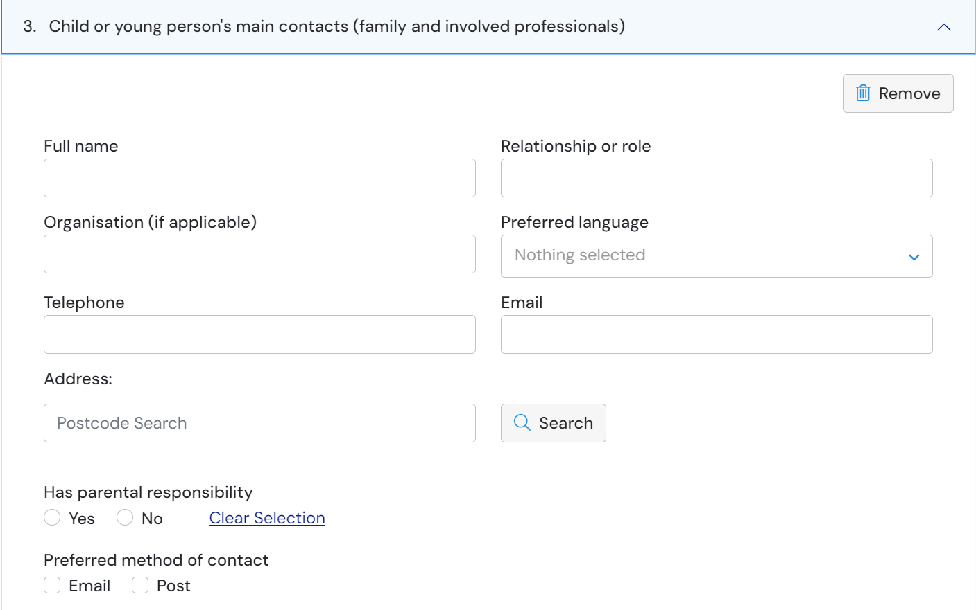
- You will then be asked to include all the names of anyone supporting your child, this can include family and professionals:

Suggested contacts may include:
- School contact / SENCo
- CAMHS
- School Nursing
- Community Paediatrician
- Child Development Centre
- Speech and Language Therapist
- Occupational Therapist
- Physiotherapist

Use the add button to add further contacts:

Section 4 –
- The next step is to add information about the education setting.
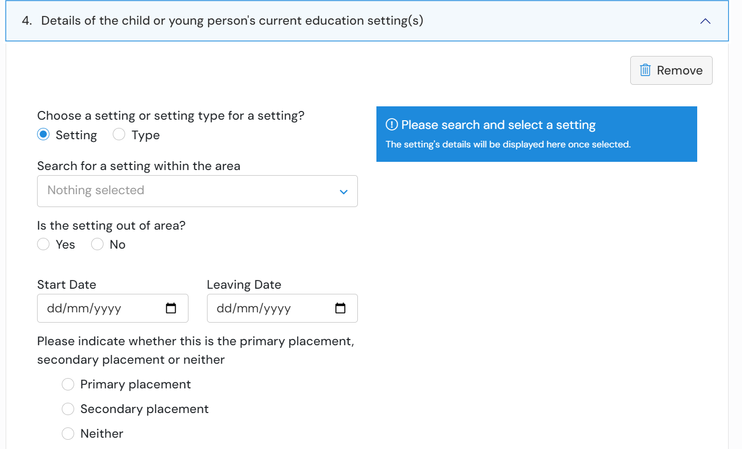

Section 5 –

Important information about the child or young person

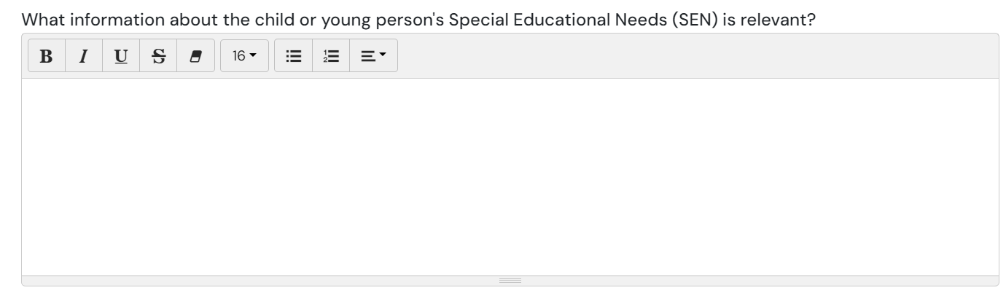
The first section is: What information about the child or young person's Special Educational Needs (SEN) is relevant?

This section is important and allows you to give the reason for applying for an Education, Health and Care needs assessment for your child/young person/ you:
Use to space to explain:
- What are your main concerns? Talk about your child’s issues/struggles and what support they require on a daily basis to carry out any tasks. Talk about what difficulties they have within the education environment – how is this being support while they are there.
  - - Do you think your child requires specialist provision? o If yes, why do you think this, what support do you feel they need that is different to what is on offer within a mainstream school?
  - o If no, what will the support of an EHCP provide within the mainstream environment?

Who have you discussed Education, Health and Care needs assessment with?
- Have you discussed with SENCO? What are their thoughts?
- Who else have you spoken with and what were their thoughts?

My child/Young Person
My child/young person’s/my early years until starting school.
- Start from pregnancy – was it a normal pregnancy, were there any difficulties/concerns during pregnancy?
- What about the birth – were there any difficulties/concerns?
- Did they meet their early developmental milestones – were they making eye contact, smiling, crawling, walking, talking etc when expected or were there concerns/delays with this?
- When did you begin having concerns about their development – how old were they, who did you speak to and what was the outcome?
- Where they referred to any children therapy services – who were they referred to, were any assessments completed and what was the outcome?
- Did they attend a nursery – when did they start nursery, how did they find nursery?
- Did nursery report any concerns to you – if they did then what were the concerns, what was done about the concerns, did nursery make any referrals?
- If they didn’t attend nursery – explain why. Was it due to needs and nurseries not being able to meet these?

What I am/my child/young person/ is like at home?
- Do they need consistency and routines in place – what does this look like? What happens if their routine is disrupted?
- How do they behave at home – are they well behaved, are they quiet, do they like to be alone, do they not get on well with siblings, do they follow instructions?
- How do they interact with the rest of the family – include yourself, the other parent/carer, siblings, grandparents, aunts, uncles and anyone else close to them. If there is a pet in the home – how do they interact with the pet?
- What do they need support with at home – think about personal care (toileting, cleaning themselves after toileting, washing, dressing, shower/bathing), eating, cooking, homework, bedtime etc. If they can carry out these tasks – do they need support to carry them out? Do they need constant prompting before they complete them? Do you have to break tasks down into manageable chunks?
- What are their play skills like – do they prefer to play alone? Are they able to play with others? Can they/Are they able to share with others? Do things have to be done their way? Do they understand ‘turn-taking’.

How my child/young person/I interact with others?
- Do they choose to interact with other adults/children? Is it on their terms only? Do they prefer not to interact with others? Do they use full sentences or one word answers?
- How do they interact with members of the family? Is it on their terms only? Do they prefer not to interact with others? Do they use full sentences or one word?
- How do they interact with their siblings? Is it on their terms only? Do they prefer not to interact with others? Do they use full sentences or one word? Do they interact through play?
- How do they interact with unfamiliar people? Is it on their terms only? Do they prefer not to interact with others? Do they use full sentences or one word
- How to they interact with different therapists and professionals? Is it on their terms only? Do they prefer not to interact with others? Do they use full sentences or one word

My child/young person’s/my strengths and what I am/he/she/ is good at?
- Identify 3 things that they are good at and whether they require support to do them – are they good at a particular sport or game? Are they good at reading? Are they good at a particular subject in school? Are they good at making others laugh?

How my child/young person/I prefer to communicate?
- Do they communicate verbally or by using gestures? What does this look like? If verbal, is it one/two words only, is it sentences? If gestures, do they point? Do they take your hand to guide you to what they want?
- Are they able to use their body language to express what they want? Can they understand other people’s body language? i.e. would they connect crying with someone being upset?
- Can they hold a two-way conversation? If someone speaks to them, can they provide an answer to continue the conversation or do they answer using one word only? Do they initiate conversation?
- How do they express their emotions? Do they express them verbally? Do they understand their emotions? Do they react in a certain way as they don’t understand their own emotions?
- Do they initiate communication? So will they start a conversation with someone familiar to them?
- Do they communicate differently with unfamiliar people? Do they engage in appointments with professionals? Do they shut down and refuse to talk?

What is important to my child/young person/me and what makes him/her/me happy?
- What makes them happy? They don’t have to common things. It could be having internet so they can use their ipad makes them happy. Is it a pet? Is it an item? Is it a person or place?
- Who is important to them in their family? This could be you, another parent/carer, grandparent, sibling or other family member. It could be the entire family.

What is your child/young person’s/my needs or difficulties and what does he/she/I need help with?
- What does your child need help with? How do you support their needs at home – visual timetables? Prompting? Routine?
- What are their communication skills like? (You can use information you have already added above)
- What are their interaction skills like? (You can use information you have already added above)
- What do they struggle to engage with? What do they refuse to do? Is it homework, leaving their bedroom, morning routine, leaving the house?
- How are they managing with school or nursery? Are they attending when they should? Do they refuse to attend? Do they bottle everything up until they come home?
- How are their self-care needs – do they do these independently or with your support? Can they do them properly? Do they need prompting? Do they have sensory needs around any part of their self care?

Education
What is working well with your child’s/young person’s/your learning at nursery/school/college and how is their/your educational progress?
- Are they attending? Do they refuse to attend? If they refuse to attend, why do they refuse? What are the difficulties they face that prevent attendance?
- How are they progressing? As expected? Behind their peers? Not at all? Are they engaging in lessons?
- How are school offering support? What is in place to support – part time timtable? Exit card? SEN pass? Small group work? Sensory room? 1:1 support?
- What have they put in place that is working well? Talk about what is working. If nothing is working, try to explain why you think it isn’t working

What difficulties is your child/young person/you having at school/college?
- Have they got social peer interaction difficulties? Do they have difficulty making and maintaining friendships? Do they avoid lunch and break times because of this?
- Do they have difficulties interacting and listening? Do they engage in lessons? Are they able to concentrate and listen to instructions? If they aren’t able to follow instructions/listen/concentrate, how does this impact on them in the classroom/with their learning?
- Do they have difficulty understanding and processing the work they are given? Do they need extra time and instructions repeated/broken down into smaller, manageable tasks?
- Do they rely on adult support to begin and remain engaged with work activities? Do they need constant prompting to remain engaged?
- Are they making academic progress? Is this progress in line with peers? Are they behind with their academic progress? Are they not making any progress? If not, go into detail about why you think this – did the school tell you, was it a teacher? The SENCo?

What needs to change and how will that change make a difference to your child/young person/you?
- What do they need to be able to progress? What other support do you think they need? Do they need smaller classes? Smaller education environment? Do you think that their needs are fully understood?
- Do you feel your child needs a specialist provision? If yes, explain why you feel this is needed.

The second section is: to complete is around health needs:
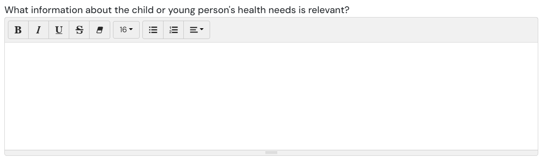

Use this to explain any diagnoses and medication and what is working well/not working well regarding health. What support is he/she/you receiving or any medication.
- Are you currently awaiting assessments for anything? If so, what are the assessments for?
- What diagnoses does your child have?
- Is your child currently taking any medication and if so, what is this for?
- Are there any therapies being offered such as speech and language therapy/Occupational Therapy etc? How often?

The Third section to complete is: around social care needs
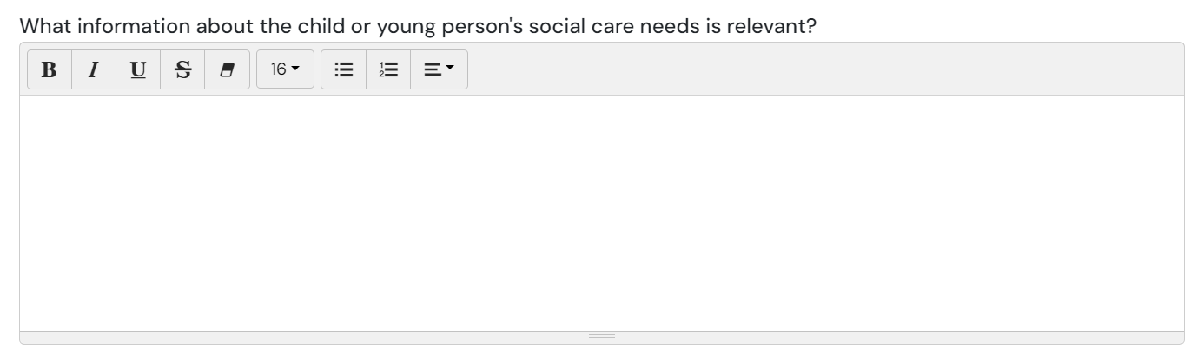

Use this to explain what is working well/not working well with regard to social care? What support is your child/young person/you receiving?
- Are Social Services or Early Help involved? If yes, consider outlining why
- How are you managing as a family to get out?
- Are you using Short Breaks service?

Section 6 –
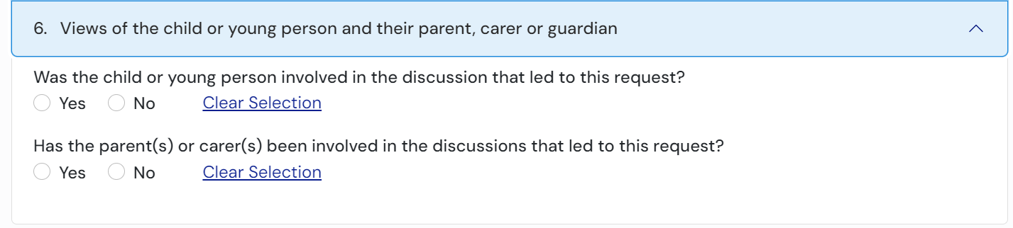
The final section allows you to add the views of the child, young person, their parent, carer or guardian:

Once completed, you can submit your request:

Things to remember:
- You are able to submit evidence online along with your contribution including diagnosis letters, reports from consultants or other professionals, school reports and anything you think demonstrates the needs of your child.

There are some useful sources of information in relation to requesting an EHC assessment:
IPSEA: https://www.ipsea.org.uk/asking-for-an-ehc-needs-assessment

Contact: https://contact.org.uk/help-for-families/information-advice-services/education-learning/ehc-plans-assessments/education-health-and-care-ehc-needs-assessments/

If you would like to discuss anything further or would like support with completing parental request you are able to contact Walsall SENDIASS on:

- Telephone: 01922 612008
- Email: walsallsendiass@family-action.org.uk

https://openobjects.vids.io/videos/ea9cdcb6181be4c163/parent-how-to-contribute-to-a-request-for-assessment

